Support for Cedar Heights and Blind Bay Village Grocer

We are on the final push towards our target sale of $60,000 of Blind Bay Village Grocer cards. We had sold just over $40,000 worth of cards by the end of September. We still have a reasonable shot at meeting our target.
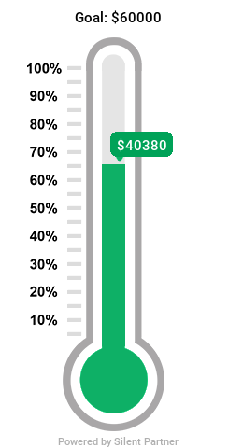
Cedar Heights purchases the cards at an 8% discount to their face value. So, when you use the card to make any purchase at the Village Grocer either in Blind Bay or in Sorrento (formerly the Lighthouse), you also are making a donation at no additional cost to you in support of our association. We cannot express our gratitude enough to the Village Grocer for their support of this program.
With Christmas season approaching, we are ordering in some cards with a face value $25 in addition to the regular array of cards having face values of up to $500. You may consider the $25 dollar cards to be stocking stuffers that will get the recipients a quarter tank of gas or a good bottle of wine, whichever is more important to them. You might also want to consider a card for one of the four Cedar Heights Christmas Gift Baskets that will be drawn at the Christmas Party. Or you might know someone who would appreciate a hand to top up their Christmas dinner table.
You can purchase your cards at the centre:
- during regular office hours (Tuesdays and Thursdays from 1 to 3 pm)
- on Friday, November 3rd after fitness class from about 10:20 am to 10:50 am
- on Saturday, November 4th from 10 am to 2 pm at the Christmas Artisan Market/Soup Kitchen
- on Friday, December 1st after fitness class from about 10:20 to 10:50 am
- on Saturday, December 9th from 10 am to 1 pm at the Christmas Bake Sale
We accept cash, cheque or debit. Sorry that we can’t accept credit cards. Too much of your donation would end up in some payment processor’s bank account.
If you haven’t done so before, please consider test driving a card. And if you have, thank you and please come back. It will be a big help to Cedar Heights.

